PRIVATE CONSULTATION FEES
(From 1/7/2024)
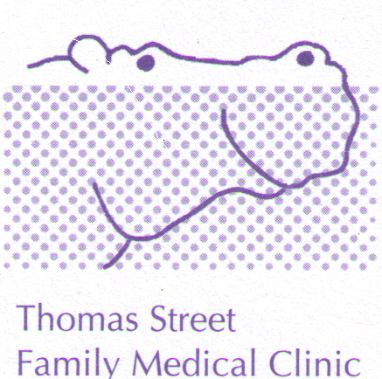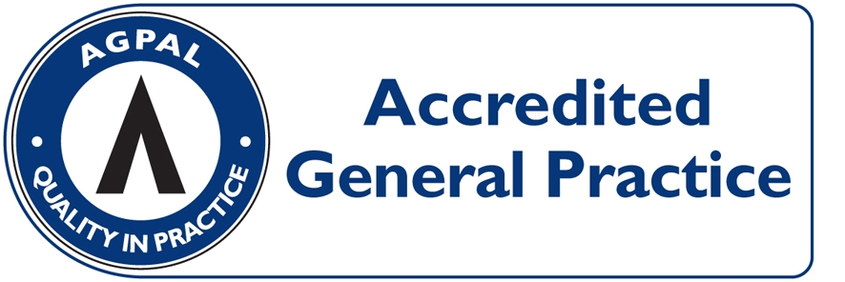
CONSULTATION | PAY ON DAY | MEDICARE REBATE  (1/7/2024) | OUT OF POCKET
LEVEL B  (STANDARD, ie 5 to 20 minutes) | $95.00 | $42.85 | $52.15
LEVEL C  (LONG, i.e. more than 20 minutes) | $140.00 | $82.90 | $57.10
LEVEL D  (PROLONGED, i.e. more than 40 minutes) | $190.00 | $122.15 | $67.85
LEVEL E  (PROLONGED, i.e. ≥ 60 minutes) | $275.00 | $197.90 | $77.10
ACUPUNCTURE  (Acupuncture + Consultation $67) | $90.00 | $42.20 | $47.80
HOME VISIT  (STANDARD) | $166.00 | $72.85 | $93.15

HEALTH CARE CARD HOLDERS: LEVEL B = $65.00 OUT OF POCKET $22.15
(INCLUDING PENSIONERS) LEVEL C = $107.00 OUT OF POCKET $24.10

ACCOUNT FEE: $20 - IF NOT PAYING ON DAY

PROCEDURES: (EG, MOLE REMOVAL) $70 OUT OF POCKET EXPENSE

CONSULTATIONS LONGER THAN 45 MINUTES AND HYPNOTHERAPY: OUT OF POCKET COSTS FROM $70.00 DEPENDING ON THE LENGH OF THE CONSULTATION (FULL FEE LIST AVAILABLE FROM RECEPTION).

CHILDHOOD VACCINATIONS: BULK-BILLED

PAYMENT OPTIONS: VISA/MASTER CARD/EFTPOS/ CASH. SORRY NO DINERS CARD OR AMEX FACILITIES

