PRIVATE CONSULTATION FEES
(From 27/05/2024)
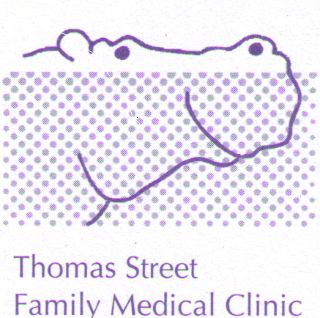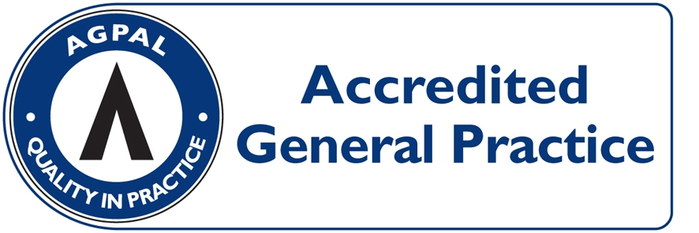
CONSULTATION | PAY ON DAY | MEDICARE REBATE  (27/05/2024) | OUT OF POCKET
LEVEL B  (STANDARD, ie 5 to 20 minutes) | $95.00 | $41.40 | $53.60
LEVEL C  (LONG, i.e. more than 20 minutes) | $140.00 | $80.10 | $64.90
LEVEL D  (PROLONGED, i.e. more than 40 minutes) | $190.00 | $118.00 | $72.00
ACUPUNCTURE  (Acupuncture + Consultation $67) | $90.00 | $40.75 | $49.25
HOME VISIT  (STANDARD) | $166.00 | $70.40 | $95.60

HEALTH CARE CARD HOLDERS: LEVEL B = $60.00 OUT OF POCKET $18.60
(INCLUDING PENSIONERS) LEVEL C = $98.00 OUT OF POCKET $17.90

ACCOUNT FEE: $20 - IF NOT PAYING ON DAY

PROCEDURES: (EG, MOLE REMOVAL) $70 OUT OF POCKET EXPENSE

CONSULTATIONS LONGER THAN 45 MINUTES AND HYPNOTHERAPY: OUT OF POCKET COSTS FROM $70.00 DEPENDING ON THE LENGH OF THE CONSULTATION (FULL FEE LIST AVAILABLE FROM RECEPTION).

CHILDHOOD VACCINATIONS: BULK-BILLED

PAYMENT OPTIONS: VISA/MASTER CARD/EFTPOS/ CASH/ CHEQUE. SORRY NO DINERS CARD OR AMEX FACILITIES

